Brewing Aztec Pulque
Background:
The Aztec civilization, a Mesoamerican culture that flourished in central Mexico in the post-classic period from 1300 to 1521 (from Aztecs, Wikipedia [7] ) brewed many forms of alcohol well before the arrival of the Spanish in the 14th century. One interesting pre-Hispanic beverage, called Pulque, has had a rich history associated with Aztec spiritual beliefs as well as secular regulation.
The Aztecs held community celebrations regularly, and historic depictions show all manner of people in society participating in consumption of pulque. Interestingly, both priests and their human sacrifices partook during their ritual sacrifices. Fortunately for most, the partaking of the drink was not limited to those particular ceremonies. Although pulque was not part of the daily diet, it was an important element of religious celebrations. Myth says that pulque comes from Mayahuel, the Goddess of the Agave plant. A very busy goddess, she had 400 children. The collective group of gods around pulque were known as the Ometochtli, sometimes known as the gods of excess.
Pulque is frequently described as a ‘milky’ beverage containing about 5% alcohol by volume (abv). Pulque is made from the sweet sap of agave (or maguey) and other plants, such as chicha corn. It appears that no plant matter was added specifically as a preservative, unlike in European and other societies during the Middle Ages, where combinations of plants were added for preservation, most prominently hops. Other plant materials were added, however, which would produce strong flavors. Another contributing flavor was the smoke from fires used to dry the corn during the malting process. Served while still fermenting, the short life of pulque made it an ideal drink for holidays.
After the arrival of the Spanish, attempts were made by the invaders to limit production of Pulque to allow more importation of alcohol from Spain. One Spanish account from 1552 suggests that within a few days after production, pulque takes on a ‘smell worse than that of a dead dog’ [4]p.137. With this drink, once fermentation has begun, it does not stop until the drink is unpalatable.
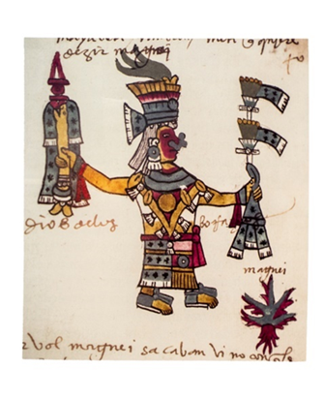
Today, pulque-like beverages are still brewed in central Mexico. Mezcal is a related drink common to the area.
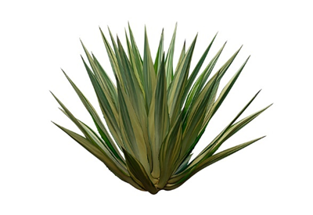

Mayahuel is considered the spirit of the agave plant and the goddess of the drink pulque itself.
The agave plant is surprisingly productive, making much sugary sap over the course of its life.
Process selection
To recreate an Aztec Pulque style beer, I turned to several books and internet resources to get a feel for the general conditions and the style. The most complete recipe I found was created by Dr. Patrick McGovern, author of “Ancient Brews Rediscovered and Recreated”. Since his work is based on chemical and physical analysis of remains and closer to the original, I think his ingredient selection will more closely approximate what was used in period.
While I was not able to obtain all the ingredients, I got almost everything (except dried guava), and hopefully this will be enough to provide a good representation of the drink.

Recipe
The original recipe calls for the following:
1 pound Purple Corn
½ pound Dried Guava (substituted 12 oz of Guava Nectar)
½ pound Fresh Prickly Pear
1 teaspoon Pectic Enzyme
3 each Fresh jalapeno
2 Tablespoons Gypsum
1 pound Brewer’s Malt (Used 2 row barley)
¼ pound Caramel malt, 40-degree Lovibond
¾ pound Cherrywood smoked malt
5 ½ pounds Agave syrup
1 ½ pounds Blue corn syrup (substituted Chicha Morada Purple Corn Drink)
1 ounce Mesquite powder (used mesquite wood chips instead)
1 packet Lallemand Belle Saison yeast

Expected Yield: Five gallons of 8.5% alcohol beer (starting gravity should be around 1.065).
** It should be noted that for my first batch, the original gravity turned out to be 1.064, slightly lower than expected. The second batch measured similarly at 1.065). This third batch has come in at 1.068 with nearly 9% potential. Since it is served while still fermenting, the drink as consumed should be somewhat lower in alcohol than that. The measurement the day before serving (March 3, 2023) was 1.030, or 4.99% ABV.

Method
There are two methods presented; the first uses a “chew and spit” traditional chicha method to get enzymes working on the purple corn. While this is a very period process, and has been used many times in modern settings, I decided to proceed with the modified process which eliminates the “chew and spit” method. I had considered using amylase enzyme to start a starch conversion of the corn, but I was fortunate to find the purple corn in an already malted form. In other words, it was already processed in a manner similar to what the chew and spit method would have achieved.
I also decided not to bottle, since accounts in various references mention that the drink was a week old, and when served, it was foaming. I surmised from this that the traditional period way of serving pulque is during primary fermentation.
Step 1: Place the dried guava in a bowl and cover with 1 gallon of water to soak (since I was using Guava nectar, the juice was poured into a bowl by itself).
Step 2: A day later, add the prickly pear to the guava and puree them together. Add the pectic enzyme and allow it to sit overnight. This significantly emulsified the prickly pear cactus from a rubbery consistency into a liquid.
Step 3: On the third day (brew day), grill the jalapenos and dice them finely.
Step 4: In a pot, bring 2 quarts of water to a boil, remove from heat, and add the crushed malted corn and gypsum. Simmer 20 minutes, stirring to prevent corn from sticking.
Step 5: Add 1-pint cold water to the corn mixture, then add the crushed malts and stir. Adjust the temperature to 122 degrees by adding colder or hotter water for ten minutes (this is a protein rest). I added more water to the mixture in order to allow the starch (and sugars) to dissolve more fully.
Step 6: After the protein rest, raise the temperature to 140 to 145 degrees and hold for thirty minutes (starch conversion). While the corn and malt mixture are resting, put 4 gallons of water in a brew pot and heat to 170 degrees.
Step 7: After the 30-minute starch conversion rest, spread a grain bag over the container holding the grains and pour the hot water into the brew pot (through the grain and grain bag). Use the grain bag like a teabag, and bounce it in the hot water to dissolve the sugars into the solution. Then hold the grain bag up and allow the water to drain without squeezing the bag. Discard the grain and the bag.
*note: I kept the bag.
Step 8: Turn up the heat to bring the solution near boiling, then remove from the heat.
Step 9: Add agave syrup and bring to a boil, for 25 minutes.
Step 10: Add the Blue corn syrup and the guava/prickly pear/pectin mixture. The Mesquite chips were added at this point. Add the diced grilled jalapeno. Boil for 5 more minutes.
Step 11: Cool mixture to 75 degrees and transfer to a fermenter. Top up to 5 gallon mark.
Step 12: Pitch yeast and begin primary fermentation. This should begin a vigorous primary fermentation within three to four days, in time to serve. I added Fermax yeast nutrient, proofed the yeast, and pitched a starter. Within 24 hours, bubbles are observed at the surface

The original instructions call for additional steps for bottling and aging, but I am serving it here in the traditional fashion during primary fermentation.

Sources:
- Ancient Brews; Patrick E McGovern, Norton 2017
- Uncorking the Past; Patrick E McGovern, University of California Press 2009
- Sacred and Herbal Healing Beers; Stephen Harrod Buhner, Brewers Publications 1998
- Alcohol a History; Rod Phillips, UNC Press, 2014
- General History of the Things of New Spain; Bernardino de Sahagun
- The Oxford Companion to Beer; Garrett Oliver, Oxford, 2011
- Aztecs, Wikipedia article

